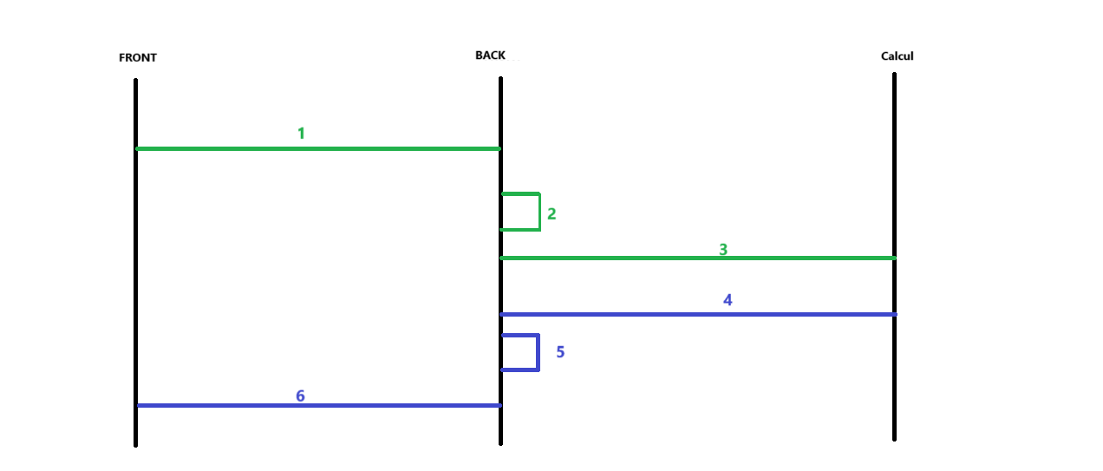

1 | FRONT | Envoi au back API avec les blocks A B et C
2 | BACK | - Enregistrement du rapport company_report  - Récupération du criteria A partir de la table Solution_report_group_config avec un join Solution_report_group en prennent en considération l’abonnement de la compagnie  - Génération de l’API générée pour calcul avec les blocs : comapnyId, B, C et D  - Sauvegarde du request dans un champ de BDD company_reports_details > Request
3 | BACK | Appel à Calcul avec les API générée  Retour avec MOCK API
4 | BACK | Récupération du résultat de calcul MOCK API
5 | BACK | Sauvegarde du résultat dans un champ de BDD company_reports_details > Request  Confirmation de la génération du rapport
6 | FRONT | Accès au rapport

Le loading de La génération du rapport sera iso au la chargement de compensation

Structure API POST
{
A
"comapnyId": 123
"title": "rapport_1",
"description": "specifique"
B
"type": "specifique",
C
"datas": {
"jobs": [
"poste1",
"poste2"
],
"compagnies": [
"compagnie_id",
" compagnie_id "
],
"sectors": [
"sector_id",
"sector_id"
]
},

"criteria": [
D

["grade"],
["collaborative_path"],
["function_code","collaborative_path","grade"],
["function_code","subfunction_code","collaborative_path","grade"]
]
}

- Config de la nouvelle BDD

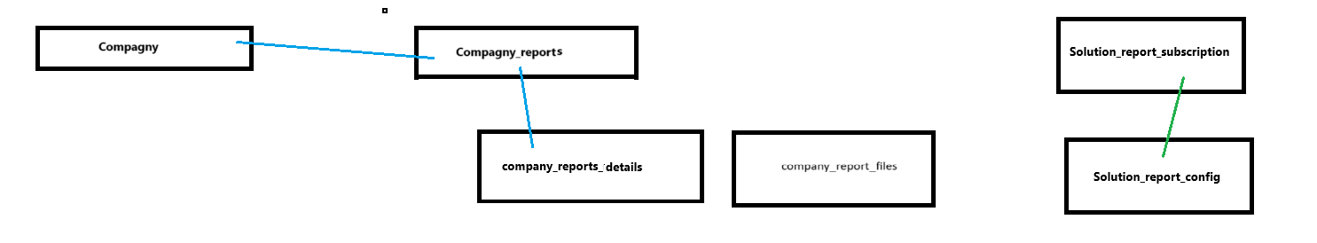
- API

Essentiel
FRONT - API | API - CALCUL
{  "type": "market",  "title": "rapport_1",  "description": "specifique"  "comapnyId" :123  "filters": {  "jobs": [],  "compagnies": [] ,  "sectors": []  }, | {  "type": "market",  "comapnyId" :123  "filters": {  "jobs": [],  "compagnies": [] ,  "sectors": []  },  "criteria": [  ["grade"],  ["collaborative_path"],  ["function_code","collaborative_path","grade"],  ["function_code","subfunction_code","collaborative_path","grade"]  ]  }

ON THE MENU

FRONT - API | API - CALCUL
{  "type": "market",  "title": "rapport_1",  "description": "specifique"  "comapnyId" :123  "filters": {  "jobs": ["job_id","job_id"],  "compagnies": ["compagny_id","compagny_id"] ,  "sectors": []  }, | {  "type": "specific",  "comapnyId" :123  "filters": {  "jobs": ["job_id","job_id"],  "compagnies": ["compagny_id","compagny_id"] ,  "sectors": []  },  "criteria": [  ["grade"],  ["collaborative_path"],  ["function_code","collaborative_path","grade"],  ["function_code","subfunction_code","collaborative_path","grade"]  ]  }

ADVANCED

FRONT - API | API - CALCUL
{  "type": "specifique",  "title": "rapport_1",  "description": "specifique"  "comapnyId" :123  "filters": {  "jobs": ["job_id","job_id"],  "compagnies": ["compagny_id","compagny_id"] ,  "sectors": []  }, | {  "type": " specifique ",  "comapnyId" :123  "filters": {  "jobs": ["job_id","job_id"],  "compagnies": ["compagny_id","compagny_id"] ,  "sectors": []  },  "criteria": [  ["grade"],  ["collaborative_path"],  ["function_code","collaborative_path","grade"],  ["function_code","subfunction_code","collaborative_path","grade"]  ]  }

