Objet : Temps de réponse API Calcul

Subscription_Type : On the menu
Report_Type : activity_domain
Request :
{
"companyId":12,
"round" : 3,
"filters": {
"business_sector": [
"BS05"
],
"companies": [
],

"jobs": [
"AFA010","AMS018","AMK019","AMK013","AJL020"
]
},
"graphs": [
"gap_general",
"general_internal_gap_fixed"
],
"criteria": [
{
"condition": [
"grade"
],
"graph": [
"repartition_gap",
"repartition_data_bf",
"repartition_data_bt"
]
},
{
"condition": [
"collaborative_path"
],
"graph": [
"repartition_gap",
"repartition_data_bf",
"repartition_data_bt"
]
},
{
"condition": [
"function_code",
"collaborative_path",
"grade"
],
"graph": [
"repartition_gap",
"repartition_data_bf",
"repartition_data_bt"
]
},
{
"condition": [
"function_code",
"subfunction_code",
"collaborative_path",
"grade"
],
"graph": [
"repartition_gap",
"repartition_data_bf",
"repartition_data_bt"
]
}
]
}
Résultat :
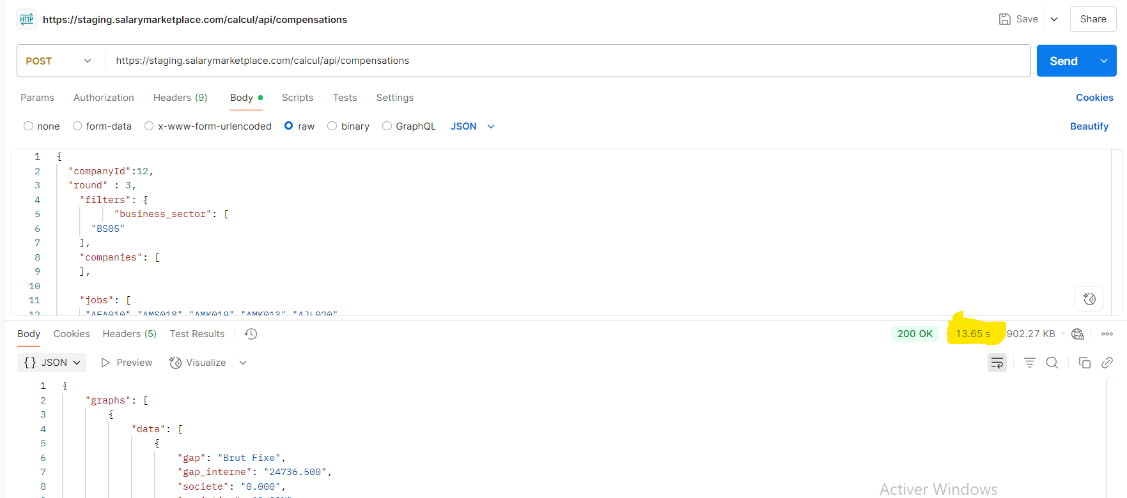

SubscriptionType : Advanced
report Type : Participant
request :
{
"companyId":3,
"round" : 3,
"filters": {
"business_sector": [

],
"companies": [
4,5,16,17,18,19,20
],

"jobs": [
"AFA010","AMS018","AMK019","AMK013","AJL020"
]
},
"graphs": [
"gap_general",
"general_internal_gap_fixed"
],
"criteria": [
{
"condition": [
"grade"
],
"graph": [
"repartition_gap",
"repartition_data_bf",
"repartition_data_bt"
]
},
{
"condition": [
"collaborative_path"
],
"graph": [
"repartition_gap",
"repartition_data_bf",
"repartition_data_bt"
]
},
{
"condition": [
"function_code",
"collaborative_path",
"grade"
],
"graph": [
"repartition_gap",
"repartition_data_bf",
"repartition_data_bt"
]
},
{
"condition": [
"function_code",
"subfunction_code",
"collaborative_path",
"grade"
],
"graph": [
"repartition_gap",
"repartition_data_bf",
"repartition_data_bt"
]
}
]
}

Résultat :
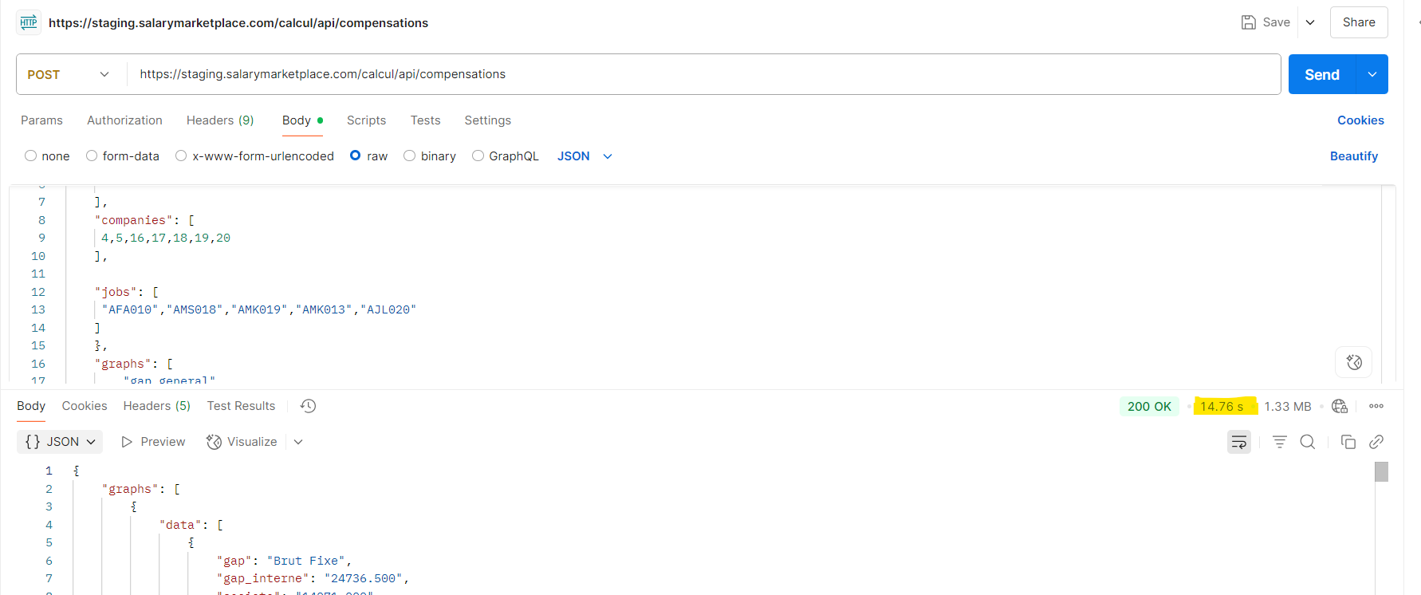

Subscription_Type : Essential
Report_Type : activity_domain
Request :
{ {
"companyId":5,
"round" : 3,
"filters": {
"business_sector": [
"BS01", "BS04"
],
"companies": [
],

"jobs": [
]
},
"graphs": [

],
"criteria": [
{
"condition": [
"grade"
],
"graph": [

]
},
{
"condition": [
"collaborative_path"
],
"graph": [

]
},
{
"condition": [
"function_code",
"collaborative_path",
"grade"
],
"graph": [

]
},
{
"condition": [
"function_code",
"subfunction_code",
"collaborative_path",
"grade"
],
"graph": [

]
}
]
}

Résultat :
