La rubrique tasks est la journalisation des actions effectuées sur la plateforme
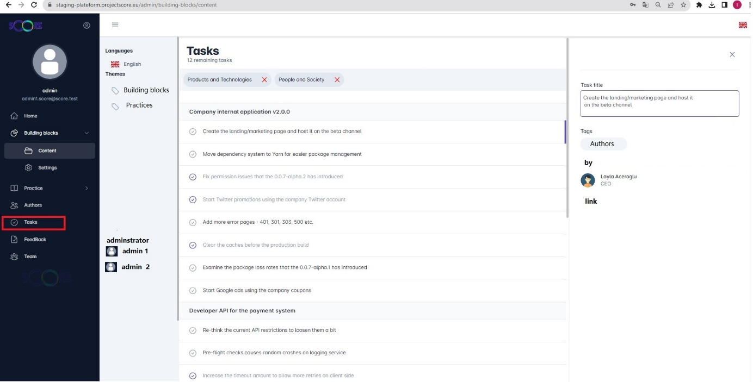

- La liste des filtres :
  - Langage
  - Thèmes
  - Administrateur
- La liste des tasks
- Lorsque je clique sur un task est caractérisé par
  - Action : contenu de task
  - Tag : type de task
  - By : qui a fait action
  - Link : lien vers la page

Comment développer la fonction

- Contrôleur avec 2 API
  - Get all task
  - Get task by id

- Un service avec une fonction qui sera appelr dans tous les autres services
Fonction (firstname, lastname, action, type, title, language)
{
Insert in table tasks
- Id task
- Id user
- Task : The user firstname lastname action type title with language language
}

Action | - Added  - Publish  - Edited  - Deleted
Type | - Building block  - Practices

building block

Building Blocks > Building Block
  - The user xxxxx xxxxx added a building block [name] with language language
  - The user xxxxx xxxxx publish a building block [name] with language language
  - The user xxxxx xxxxx edited a building block [name] with language language
  - The user xxxxx xxxxx deleted a building block [name] with language language

Practices
Practices > Practices
  - The user xxxxx xxxxx added a practice [name] with language language
  - The user xxxxx xxxxx publish a practice [name] with language language
  - The user xxxxx xxxxx edited a practice [name] with language language
  - The user xxxxx xxxxx deleted a practice [name] with language language

