Feedback page:
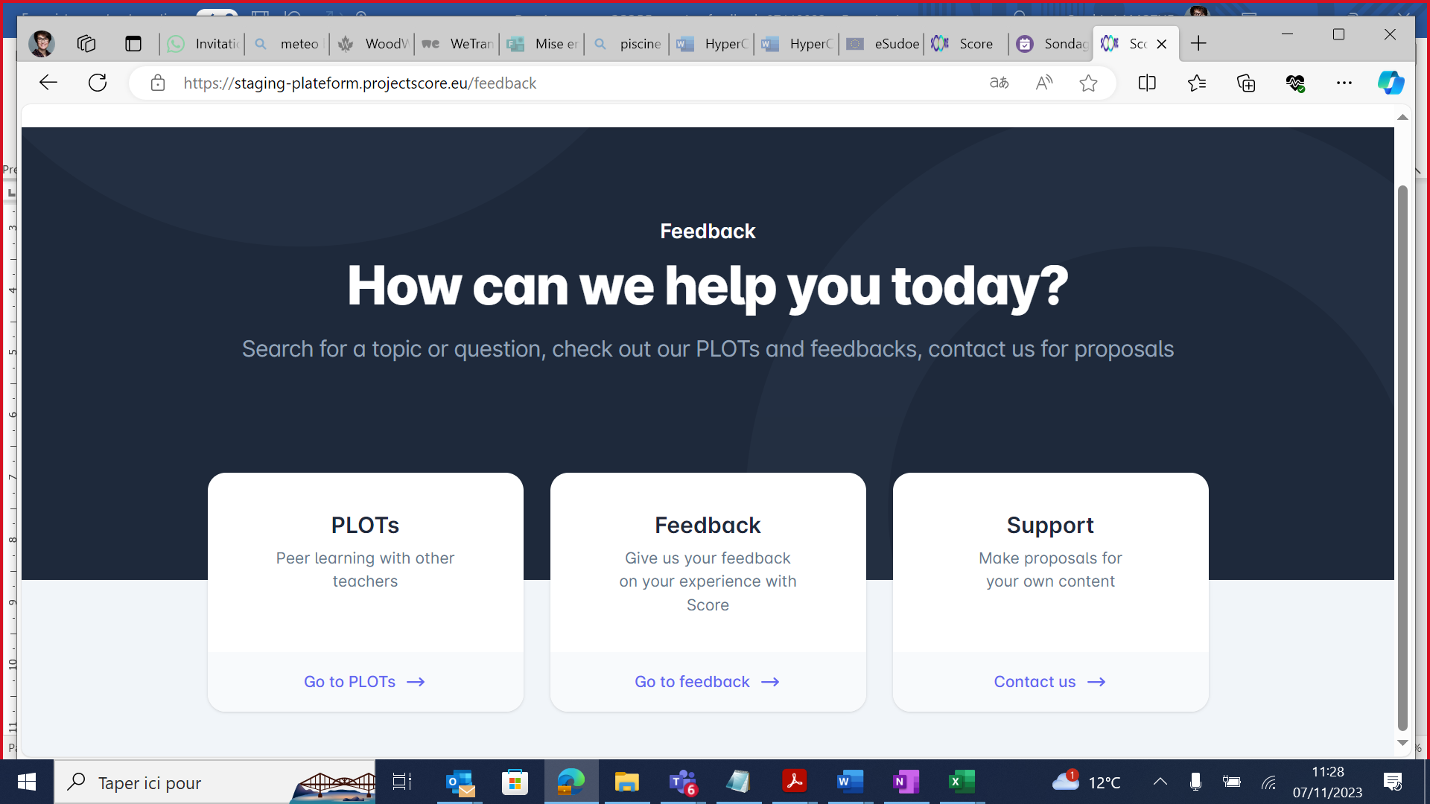

Section titles
Àla place de PLOTs > tu mets Share et en dessous “Join the SCORE community”
Instead of Support > Contribute

PLOTs (Share) section
Rajoute: Join the SCORE community on discord: https://discord.gg/XXssXCxk

Support (Contribute) section
Au sein de Contribute : ajouter des modèles avec des sections de plate-forme afin qu'il soit facile de copier et de coller si le matériel est intéressant.
Model 1: https://docs.google.com/forms/d/e/1FAIpQLSedlGkjiPUOTWOQbJfJ5ZLlooo0aCTxkBezmVoTNOuivIPV2g/viewform?pli=1
Model 2: https://docs.google.com/forms/d/e/1FAIpQLSfhT6_2ADwKd80gh1QjZkuRbYYyCsaMdH1OkP_BWCtKNBuCWA/viewform

Feedback section
We propose the following questions/sections:
Name
Email
What material are you assessing, have you used?
How do you rate this material?
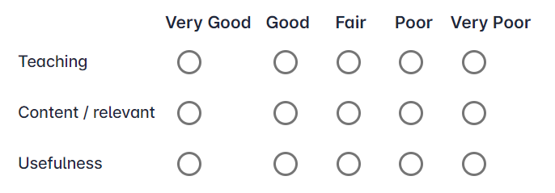
Do you feel more confident on the subject?
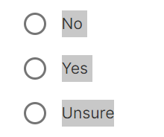
Have you missed something?
Do you have suggestions?

